October 2013: ISSUE 49

CONTENTS:
- Welcome Note from the Commissioner ………..…..……………………..1
- Letter from the Executive Director …….………………………………….2
- Club Highlight –Toreros Volleyball Club ……………….3
- Fall League Volleyball Championships ………………………………5
- Annual Jr. Forum Meetings ………………………………….………………5
- 2012/2013 Florida Region Highlights ………………………………..6
- Girls’ Junior Club Tryout Dates ……………………………..8
- Florida Volleyball Festival – Daytona Beach, FL ………………………..8
- Florida Volleyball In The News …………………………………………….9
- Update From The Commissioner – Mary Andrew ………………….9
- USAV Membership Renewal …….…….……………………………………9
- Membership Count Update ……..………………………………………10

WELCOME NOTE FROM THE COMMISSIONER

LETTER FROM THE EXECUTIVE DIRECTOR

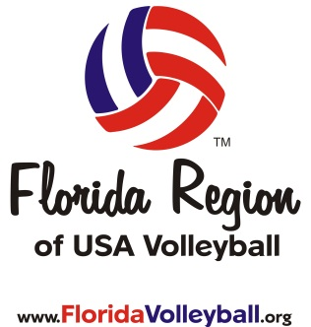

Steve Bishop, Executive Director
Florida Region of USA Volleyball

E-Mail: steve@floridavolleyball.org

CLUB HIGHLIGHT – RIVERS VOLLEYBALL CLUB
Each month a member club is featured in Vol-eNews. This is a great way to get to know the Club Director(s) and learn more about the clubs throughout Florida. This month Manh Duong and Rivers Volleyball Club will be highlighted.

Thanks Manh for participating in the Club Highlight. The Florida Region wishes you and your club success in the 2013/2014 season! Stay tuned for next month’s Club Highlight to learn about Manh Duong and Rivers Volleyball Club!

FALL LEAGUE VOLLEYBALL CHAMPIONSHIPS
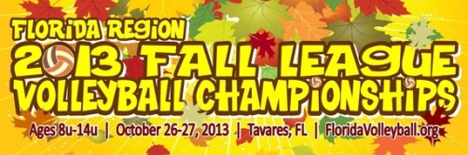
Event: 2013 USAV Fall League Volleyball Championships
Age Divisions: 8u/10u/11u/12u/13u/14u
Date: Oct 26, 2013
Location: The Big House Sports Complex
Address: 1544 Lane Park Cutoff Rd., Tavares, FL 32778
Team Fee: $150 by Oct 1, $200 After
# of Courts/Teams: 12-16 courts/48-64 teams
Deadline to Register: Friday, Oct 11, 2013 @ 5pm!

ANNUAL JR. FORUM MEETINGS
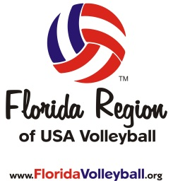
Beginning in 2013, girl's indoor jr. club directors will no longer be required to attend an annual jr. forum meeting unless you were a new club director in the 2012/2013 season and did not attend a district jr. forum meeting in August of 2012 (these club directors are required to attend the jr. forum meeting in November 2013). Also, any new club director(s) of any club, no matter how many years the club has been active, must attend the jr. forum meeting in November 2013. The format of the new meetings has been changed to an educational/best practices format. The Florida Region staff will now prepare an annual written update and distribute that to all clubs via email and on this page of the region website. Note: Clubs that are required to attend and do not will incur a $500 fine and will not be recognized as a USAV club in good standing until the fine has been paid in full. This is a standing mandate from the Florida Region Board of Directors.
SCHEDULE SESSIONS AVAILABLE
Nov. 2, 2013 -New Club Director Meeting
West Palm Beach (Exact Location TBA) -Club Admin Training
Time: 9a to 4p -AES/WebPoint Training
-Branding/Marketing/Promotions
Nov. 3, 2013 -Bookkeeping/Accounting
Ocala, FL (Exact Location TBA) -Risk Management
Time: 9a to 4p -Grass Roots Programming
-IMPACT Coaching Clinic

GIRLS’ JUNIOR CLUB TRYOUT DATES
The earliest date that a USAV sanctioned tryout in the Florida Region may be held for junior female athletes, 15 years old & up, is November 17th! Any club found to be holding tryouts prior to this date will be subject to fines and/or penalties.
Please make sure that you sanction your USAV tryouts at least 30 days in advance so it can receive an event sanction number and a USAV certificate of insurance. If you have any questions, please contact SBenson@FloridaVolleyball.org.

FLORIDA VOLLEYBALL FESTIVAL – DAYTONA BEACH, FL
This year the Florida Region will be hosting the 1st Annual Florida Volleyball Festival in Daytona Beach, FL Jan 3-5, 2014. The events included will be as follows:
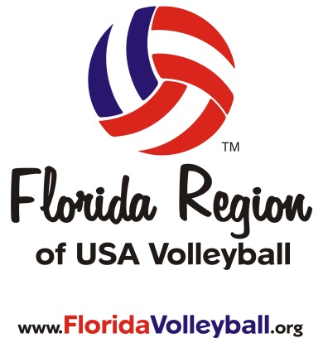
- Boys Pre-Q Tournament
- Girls Club Cup Tournament
- Adult Friday Night Series
- FCVL College Club Tournament
- Florida Region Coaching Clinics
- Regional Official’s Clinic
- National Official’s Clinic
- Boys Team Florida HP Tryout
- Florida WAVE Pro VB Tryout (M&W)

Stay tuned for more info!

UPDATE FROM THE COMMISSIONER – MARY ANDREW

USAV MEMBERSHIP RENEWAL
September 1st, 2013 marked the beginning of the 2013/2014 membership season for USA Volleyball and all current memberships expire on October 31, 2013. You can renew your USAV Membership by logging into your account and clicking “To Apply for Your Membership Click Here” located at the top of the screen. If you have any questions, please contact Office@FloridaVolleyball.org.

MEMBERSHIP COUNT UPDATE
Help the Florida Region meets its membership goal of 13,000…please let others in your area know about the playing, coaching, and officiating opportunities offered by USA Volleyball in the Florida Region. Thank you to all of you for supporting USA Volleyball!

REGION INFORMATION
Florida Region of USA Volleyball, Inc. T: (352) 742-0080
15010 US Highway 441 F: (352) 414-5304
Eustis, FL 32726 E:office@FloridaVolleyball.org

Web: www.FloridaVolleyball.org

Board Members: Staff:
Mary Andrew, Commissioner Steve Bishop, Exec. Director/President
Doug Darling, Asst. Commissioner Steve Benson, Sport Development Mgr.
Donna Beasley, Secretary/Treasurer Michele Sisser, Registrar/Office Mgr.
Sam Skelton, Indoor Chair Heather Cormier, Events Coordinator
Nancy Cothron, Outdoor Chair Sue Wainio-Oato, Official’s Coordinator Darin Clark, Official’s Chair

Junior Admin Board (JAB) Representatives:

Lori Eaton, Russel Williams, Rita Crockett, Carrie Prewitt

OFFICIAL FLORIDA REGION CORPORATE PARTNERS
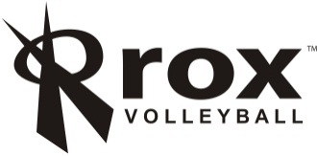

The Official Outfitter of the Team Florida Beach HP All-Star Program!
The Official Indoor Volleyball of the Florida Region of USA Volleyball!
The Official Outfitter of the Florida Region HP All-Star Program since 2006!
The Official Outdoor Volleyball of the Florida Region of USA Volleyball!

OFFICIAL FLORIDA REGION BUSINESS PARTNERS

